서로에게 청년부2월 행사
(To1Another Ministry Events in Feb 2012)
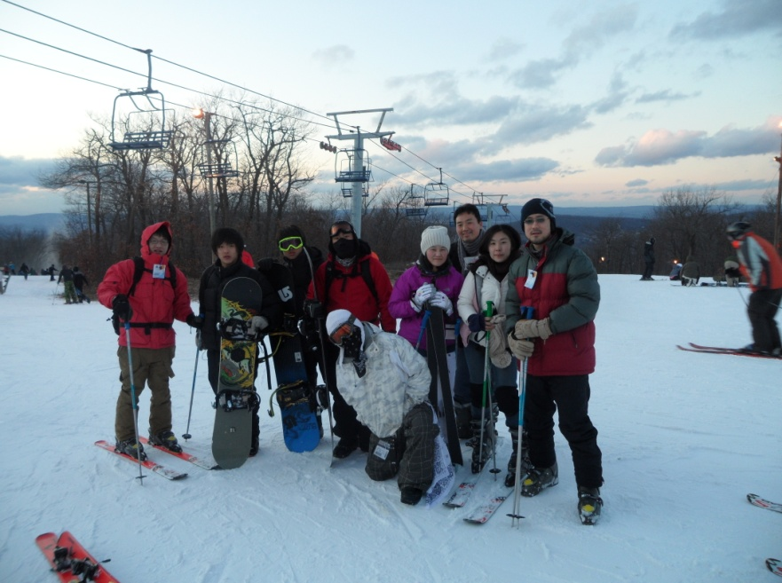
또 스키 타러 갑니다
Skiing again at Mountain Creek, NJ
Mid-Feb12

주일 성경 공부
Every Lord’s Day
After fellowship @ 12:30pm
주일마다, 친교 후, 12:30시에

Superbowl 46 - Giants vs Patriots
Meet at the shed 5:30pm, February 5, 2012
Food: To be determined (Recommendations are welcome)

HD on 150” screen. RSVP on facebook

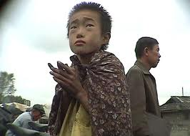
북한에 대한 비디오 보고 나누기
Watch a Video on North Korea and Share
(북한은 청년부 (서로에게)의 선교 목표 나라 입니다)
(North Korea is To1Another’s focus country for Missions)
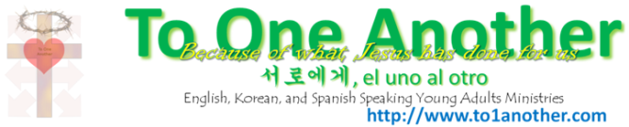
Mid-Feb12

